# User Guide

## Generating the Matrix:

To generate the matrix run the python cell with the title ‘Generate Matrix’ in the notebook with the CollateAssesments spreadsheet closed.

Run the cell. If no message is returned then the matrix has been generated to the Matrix sheet in the excel document.

If a message in the format,

'Problem solving' tag is not listed on Outcomes table,

Appears then the quoted phrase must be added to the outcomes table. Do this by entering the exact phrase under Outcome in the outcomes table and marking 1 for the relevant columns and 0 for the rest.

Then run the cell again. Repeat this until you no longer get a message in that format.

## Adding entries:

When adding entries ensure that all naming and spelling is consistent, especially the course name. Also ensure that all lists are comma space separated meaning each entry is separated from the others by ‘, ’. Go to sheets to see what each data should be entered to each column

### Types

When filling the Types column for an assessment if you’d like to ensure it is categorized as practical, communication, reflective or theory add that term as a tag, with all lower case letters. When adding other types try to use types that have already been mentioned in previous entries.

### Learning Outcomes in Courses

When filling the LearningOutcomes column try to use keywords that exist on the Outcomes table. After adding a course attempt to generate a matrix to ensure that all outcomes have been fulfilled correctly.

### Outcomes fulfilled in assessments

When filling the OutcomesFulfilled column use only keywords from LearningOutcomes entry for the course that contains the assessment.

# Sheets

## Assessments:

|  |  |  |
| --- | --- | --- |
| **Column** | **Data Type** | **Info** |
| Course | String | The name of the course the assessment is part of |
| Assessment name | String | The name of the assessment |
| Percentage | Float between 0 and 1 | The percentage of the course that the assessment is worth |
| End date | Date | Due date of the assessment |
| Types | string | A list of traits describing how the assessment is done. Separated by “, ” |
| Outcomes fulfilled | string | The learning outcomes that this assessment fulfils as a list separated by “, ” |
| Word Count | integer | The word count for the assessment if defined |
| Data set used | string | A comma separated list showing the names of the datasets used by an assessment if any |

## Courses:

|  |  |  |
| --- | --- | --- |
| Column | Data Type | Info |
| Course | String | Name of the Course |
| Organiser | String | The course Organiser |
| Secretary | String | The course Secretary |
| Year | Integer | The year the course is intended for |
| Block | Integer | The block that this course takes part in |
| Credits | Integer | How many credits the course is worth |
| Course end date | Date | The end date of the block containing the course |
| Learning outcomes | String | The learning outcomes the course describes as a list separated by “, “ |
| Leads | String | The leads for the course as a list separated by  “, ” |
| Lecturers | String | The lecturers for the course as a list separated by  “, ” |
| Tutors | String | The Tutors for the course as a list separated by  “, ” |

**many courses only say who the Organiser and Secretary are in terms of staff.

## Credited:

The credited dataset table contains all information in the above tables matched by course name and:

|  |  |  |
| --- | --- | --- |
| Column | Data Type | Info |
| Credit | float | The amount of credits the individual assessment is worth |
| Time after course end | integer | The time between the course end date and the assessment due date |
| Category | A string saying ‘Communication’ or  ‘Practical’ or  ‘Theory’ or  ‘Reflective’ | Determined by the assessments tags |

## Matrix

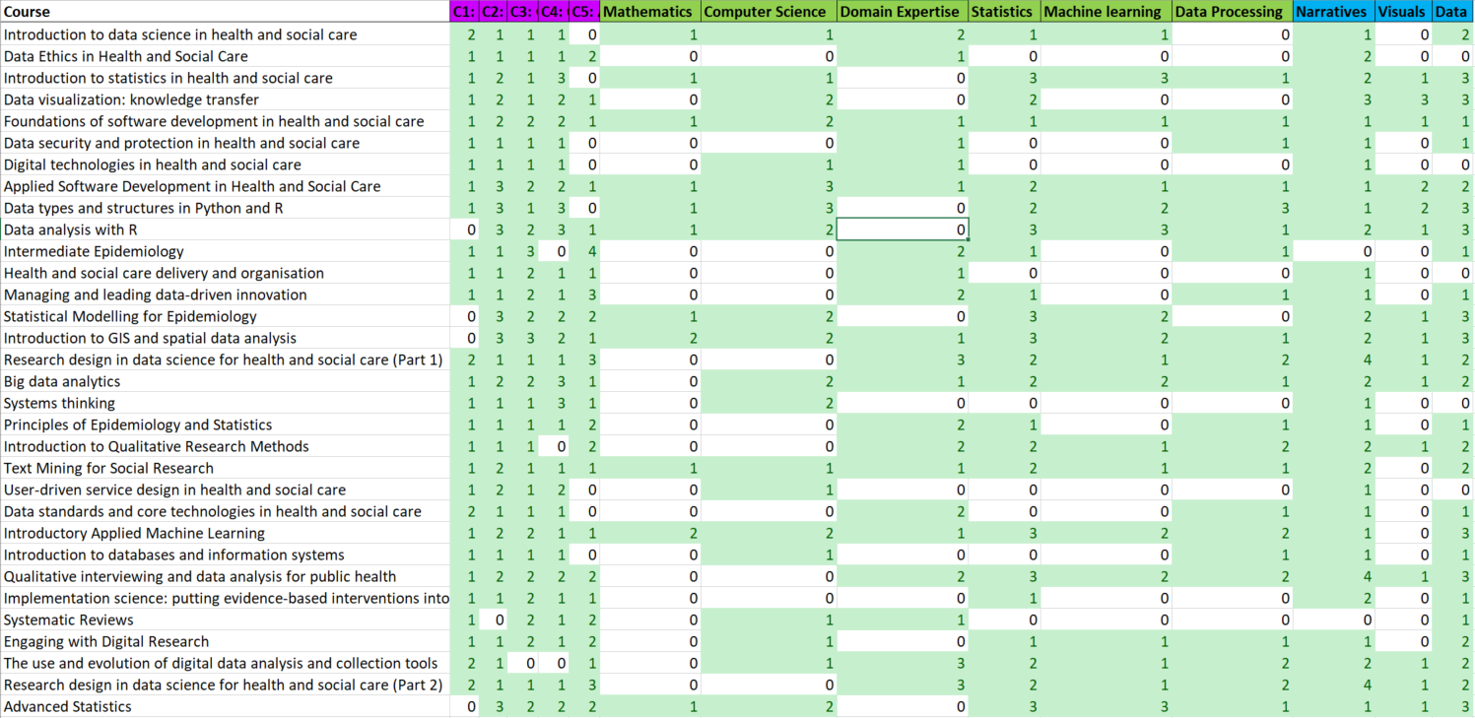This matrix shows how many learning outcomes related to one of the column headings are fulfilled by each course. To make a matrix see generate matrix

## Outcomes

Another matrix that shows what learning outcomes relate to values on the main matrix. Showing 1 if that outcomes fulfils that objective and 0 otherwise.

## Visualizations

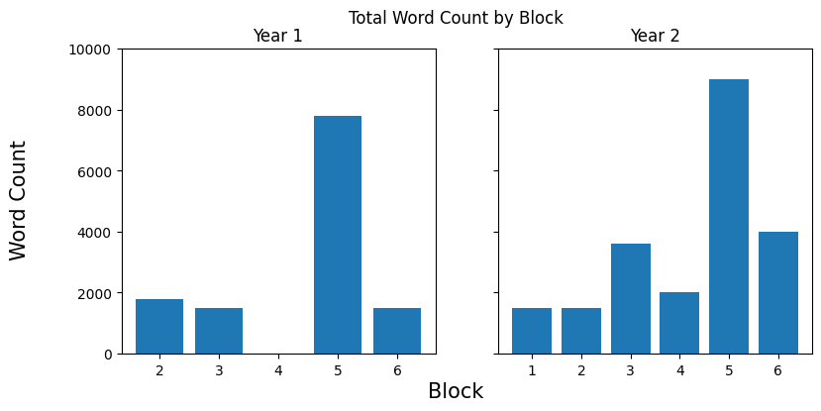

** blocks 1 and 2 in first year are combined so 2 in that table represents both of them.

